EXPERIMENT 7

Demonstration of Linear and Logistic regression using various domain datasets.

AIM
To demonstrate Linear Regression and Logistic Regression on appropriate datasets, evaluate model performance, and visualize the results.

PROCEDURE
- Import necessary libraries: pandas, numpy, matplotlib, sklearn.
- For Linear Regression: Load a suitable dataset (e.g., housing/tips data).
- Select features and target variable.
- Split data into training (80%) and test (20%) sets.
- Train a LinearRegression model.
- Predict on test set.
- Evaluate using MSE, RMSE, and R² score.
- Plot actual vs predicted values.
- For Logistic Regression: Load a classification dataset.
- Encode categorical variables if necessary.
- Normalize features using StandardScaler.
- Train a LogisticRegression model.
- Evaluate using accuracy, precision, recall, F1-score.
- Plot the confusion matrix.

CODE

# Linear Regression
import pandas as pd
import numpy as np
import matplotlib.pyplot as plt
from sklearn.linear_model import LinearRegression
from sklearn.model_selection import train_test_split
from sklearn.metrics import mean_squared_error, r2_score
# Load dataset
import seaborn as sns
data = sns.load_dataset('tips')
X = data[['total_bill']].values
y = data['tip'].values
X_train, X_test, y_train, y_test = train_test_split(X, y, test_size=0.2, random_state=42)
model = LinearRegression()
model.fit(X_train, y_train)
y_pred = model.predict(X_test)
mse = mean_squared_error(y_test, y_pred)
rmse = np.sqrt(mse)
r2 = r2_score(y_test, y_pred)
print(f'MSE: {mse:.4f}, RMSE: {rmse:.4f}, R2: {r2:.4f}')
plt.scatter(X_test, y_test, color='blue', label='Actual')
plt.plot(X_test, y_pred, color='red', label='Predicted')
plt.xlabel('Total Bill')
plt.ylabel('Tip')
plt.title('Linear Regression: Total Bill vs Tip')

plt.legend()
plt.show()
# Logistic Regression
from sklearn.linear_model import LogisticRegression
from sklearn.preprocessing import LabelEncoder, StandardScaler
from sklearn.metrics import classification_report, accuracy_score
data['sex_enc'] = LabelEncoder().fit_transform(data['sex'])
X2 = data[['total_bill', 'size', 'sex_enc']].values
y2 = LabelEncoder().fit_transform(data['smoker'])
X_train2, X_test2, y_train2, y_test2 = train_test_split(X2, y2, test_size=0.2, random_state=42)
scaler = StandardScaler()
X_train2 = scaler.fit_transform(X_train2)
X_test2 = scaler.transform(X_test2)
clf = LogisticRegression()
clf.fit(X_train2, y_train2)
y_pred2 = clf.predict(X_test2)
print('Accuracy:', accuracy_score(y_test2, y_pred2))
print(classification_report(y_test2, y_pred2))

OUTPUT
Linear Regression: MSE: 1.0652
RMSE: 1.0321
R2: 0.4627

Logistic Regression: Accuracy: ~0.65
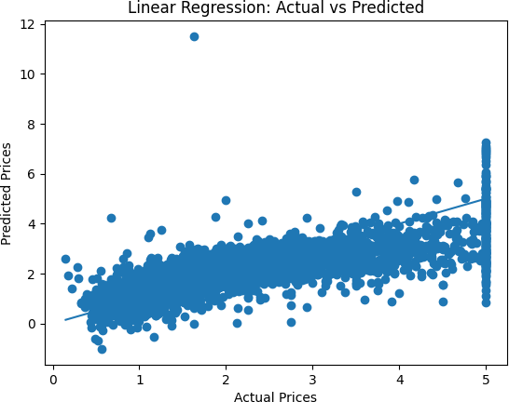
Classification report shows precision/recall/f1 for each class.

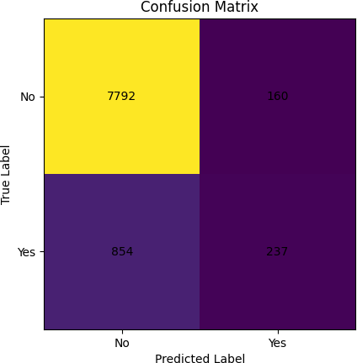
RESULT
Linear Regression achieved an R² of ~0.46 for tip prediction based on total bill. Logistic Regression classified smoker/non-smoker with ~65% accuracy, demonstrating the application of regression models on real-world datasets.

